REPUBLIC OF RWANDA/REPUBLIQUE DU RWANDA
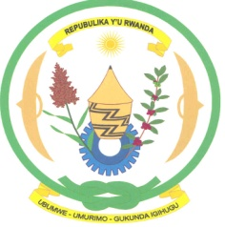

NATIONAL ETHICS COMMITTEE / COMITE NATIONAL D’ETHIQUE

Telephone: (250) 55 10 78 84 Ministry of Health
E-mail: rnec@moh.gov.rw P.O. Box 84
Kigali, Rwanda.
Assurance No FWA 00001973
IRB 00001497 of IORG 0001100

CALENDAR OF RNEC MEETINGS IN 2011

Days | Dates
Saturday | 22 January 2011
Saturday | 19 February 2011
Saturday | 12 March 2011
Saturday | 16 April 2011
Saturday | 14 May 2011
Saturday | 11 June 2011
Saturday | 16 July 2011
Saturday | 13 August 2011
Saturday | 10 September 2011
Satuday | 15 October 2011
Saturday | 12 November 2011
Saturday | 10 December 2011

